Project Development Phase
Model Performance Test

Date | 15 February 2026
Team ID | LTVIP2026TMIDS77787
Project Name | Electric Motor Temperature Prediction using Machine Learning
Maximum Marks

Model Performance Testing:
Project team shall fill the following information in model performance testing template.
S.No. | Parameter | Values | Screenshot
 | Model Summary | A custom object named Motor Sensor Data was created in Salesforce to store motor dataset records. Custom fields such as Voltage, Current, Torque, Speed, and Temperature were configured under the object. This setup ensures structured data storage and proper management of motor-related information within the Salesforce platform. | 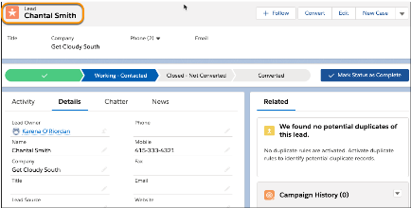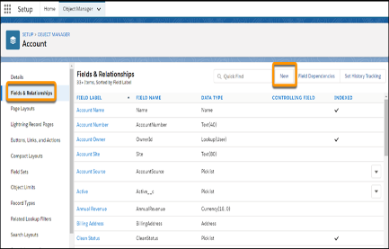  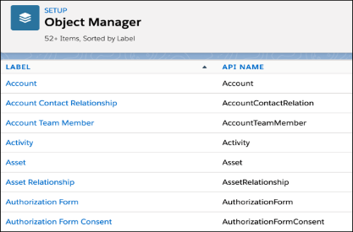
 | Accuracy | Training Accuracy – Not Applicable  Validation Accuracy – Not Applicable  Salesforce was used for data storage and automation setup. Machine Learning training and validation accuracy were calculated separately in the Python-based regression model.
3. | Confidence Score (Only Yolo Projects) | Not Applicable – This project uses regression-based temperature prediction and does not involve object detection or confidence scoring models such as YOLO.

